**ASSIGNMENT 2.2**

Create a sample dataset and implement the below Pig commands on the same dataset.

**Dataset:**

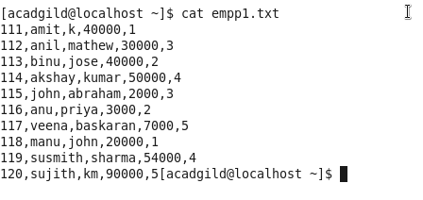

**Loading the file to hdfs:**

**C:\Users\skm\Pictures\snap\A5\Capture1.PNG**

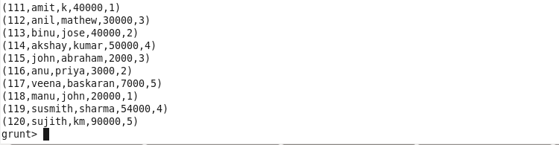

**1)Concat**



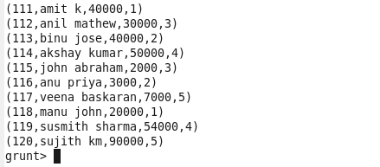

**C:\Users\skm\Pictures\snap\A5\Capture5.PNG**

**2) Tokenize**

First load the file as single line

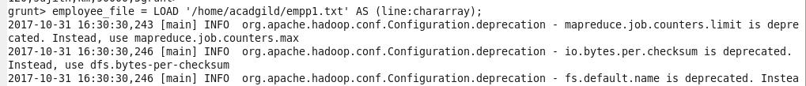

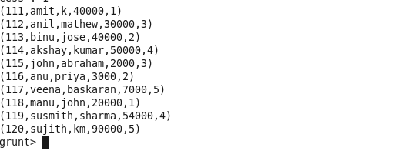

**C:\Users\skm\Pictures\snap\A5\Capture8.PNG**

**Output for tokenized file:**

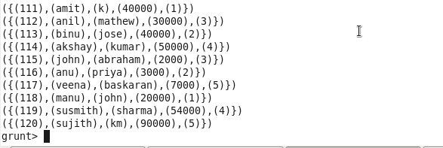

Grouping the data based on rating for performing aggregate operation

**C:\Users\skm\Pictures\snap\A5\10.PNG**

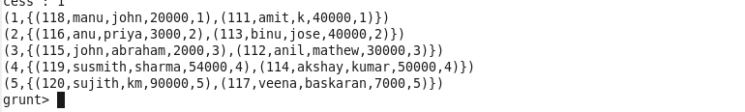

**3)Sum**



**output**

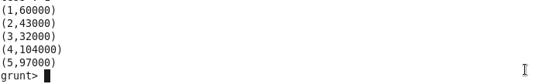

**4)Min**

**C:\Users\skm\Pictures\snap\A5\14.PNG**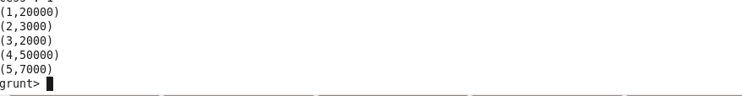

**5)Max**

**C:\Users\skm\Pictures\snap\A5\16.PNG**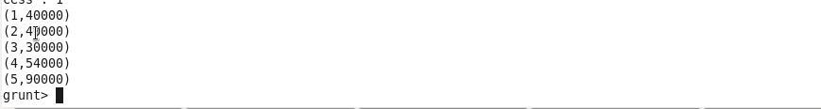

**6)Limit**

**First sort the file:**

**C:\Users\skm\Pictures\snap\A5\18.PNG**

**Apply limit**

**C:\Users\skm\Desktop\new.PNG**

**C:\Users\skm\Desktop\new1.PNG**

**Output**

**C:\Users\skm\Pictures\snap\A5\19.PNG**

**7)Store**

**C:\Users\skm\Pictures\snap\A5\20.PNG**

**output**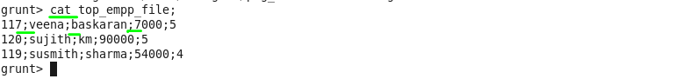

**8)Distinct**

**C:\Users\skm\Pictures\snap\A5\23.PNG**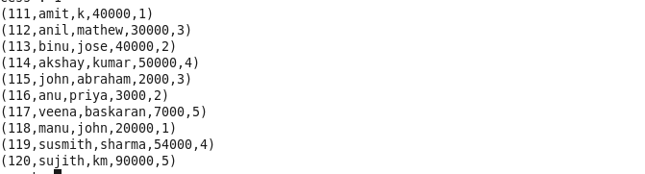

**10) Flatten**

**C:\Users\skm\Pictures\snap\A5\25.PNG**

